<!DOCTYPE html>
<html>
<head>
<title>Login</title>
</head>
<body>

<h2>Login Page</h2>
<form action="LoginServlet" method="post">
Username: <input type="text" name="username"><br><br>
Password: <input type="password" name="password"><br><br>
<input type="submit" value="Login">
</form>
</body>
</html

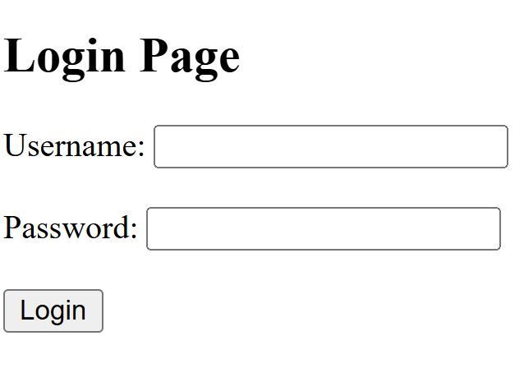
OUTPUT

